Daiwa Capital Markets Hong Kong Limited WARNS AGAINST FRAUDULENT WEBSITE

Daiwa Capital Markets Hong Kong Limited and Daiwa Securities Group would like to alert its customers and the public to a fraudulent website: Daiwazj.com

Daiwa Securities Group would like to remind its customers and public that it has no connection with this fraudulent website.

Below is the screen capture of the fraudulent website.

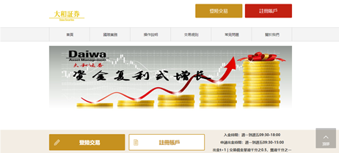

The domain name of the Daiwa Securities Group is: http://www.daiwa-grp.jp/english/index.html .

The domain name of Daiwa Capital Markets Hong Kong Limited is http://www.hk.daiwacm.com/ .

The domain names of relevant Daiwa Securities Group Companies are also set out in Daiwa Securities Group’s web-site: http://www2.daiwa-grp.jp/english/about/about_12.html .

If customers and anyone are concerned they may have disclosed their details to suspicious parties, they should report to the relevant authorities in their jurisdictions.

